**3.1 Structural Modeling**

**3.1.2 Flowchart modeling**

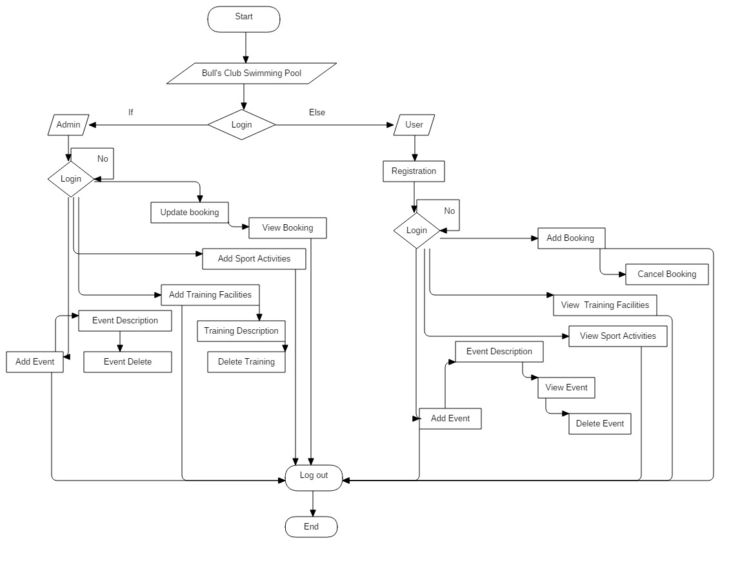

*Fig 3.1.2 Flowchart*

**3.3 Database modeling**

**3.3.1 Data dictionary**

***User Table***

|  |  |  |  |  |
| --- | --- | --- | --- | --- |
| **Attributes** | **Datatype** | **Primary Key** | **Foreign Key** | **Nullable** |
| User_id | int(10) | Yes | No | No |
| First name | varchar(50) | No | No | No |
| Last name | varchar(50) | No | No | No |
| Email | varchar(50) | No | No | No |
| Contact no | bigint(50) | No | No | No |
| Address | varchar(50) | No | No | No |
| Gender | enum | No | No | No |
| Password | varchar(25) | No | No | No |

***Admin Table***

|  |  |  |  |  |
| --- | --- | --- | --- | --- |
| **Attributes** | **Datatype** | **Primary Key** | **Foreign Key** | **Nullable** |
| Admin_id | int(10) | Yes | No | No |
| username | varchar(100) | No | No | No |
| password | varchar(50) | No | No | No |
| Email | Varchar(40) | No | No | No |

***Events Table***

|  |  |  |  |  |
| --- | --- | --- | --- | --- |
| **Attributes** | **Datatype** | **Primary Key** | **Foreign Key** | **Nullable** |
| Events_id | int(10) | Yes | No | No |
| User_id | int(10) | No | Yes | No |
| Admin_id | Int(10) | No | Yes | No |
| Events name | varchar(150) | No | No | No |
| Events time | time | No | No | No |
| Events date | date | No | No | No |
| Events description | varchar(200) | No | No | No |
| Events title | varchar(20) | No | No | No |
| Events venue | varchar(20) | No | No | No |

***Booking Table***

|  |  |  |  |  |
| --- | --- | --- | --- | --- |
| **Attributes** | **Datatype** | **Primary Key** | **Foreign Key** | **Nullable** |
| Booking_id | int(10) | Yes | No | No |
| User_id | Int(10) | Yes | No | No |
| Booking contact person | varchar(100) | No | No | No |
| Booking time | time | No | No | No |
| Booking date | date | No | No | No |
| Contact no | bigint(50) | No | No | No |
| Contact email | varchar(50) | No | No | No |

***Training Table***

|  |  |  |  |  |
| --- | --- | --- | --- | --- |
| **Attributes** | **Datatype** | **Primary Key** | **Foreign Key** | **Nullable** |
| Training_id | int(10) | Yes | No | No |
| User_id | int(10) | No | Yes | No |
| Admin_id | int(10) | No | Yes | No |
| Booking_id | int(10) | No | Yes | No |
| Training name | varchar(100) | No | No | No |
| Training description | varchar(200) | No | No | No |
| Training time | time | No | No | No |
| Training date | date | No | No | No |

***Sports Table***

|  |  |  |  |  |
| --- | --- | --- | --- | --- |
| **Attributes** | **Datatype** | **Primary Key** | **Foreign Key** | **Nullable** |
| Sports_id | int(10) | Yes | No | No |
| User_id | Int(10) | No | Yes | No |
| Sport name | varchar(100) | No | No | No |
| Sport description | varchar(250) | No | No | No |

**3.5 Protyping Design**

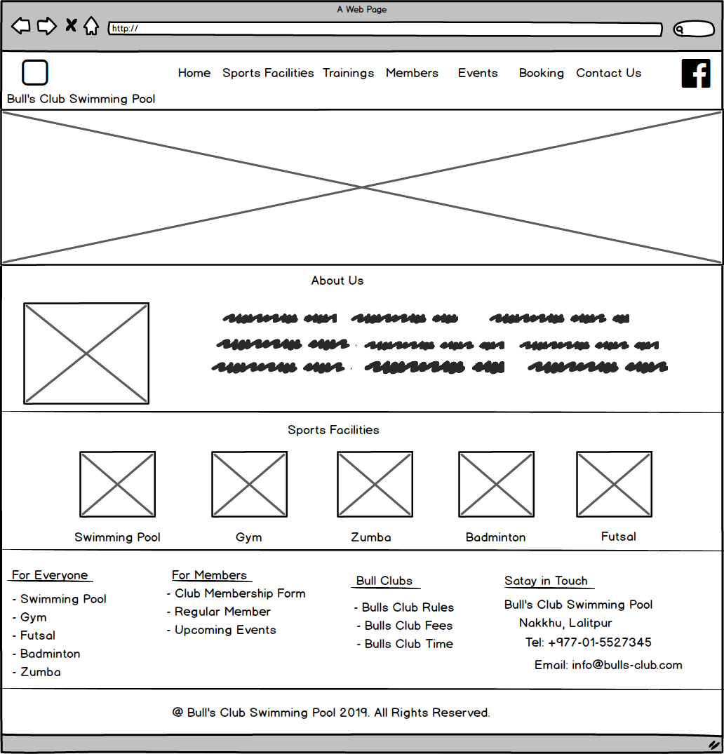

*Fig 1 : Homepage*

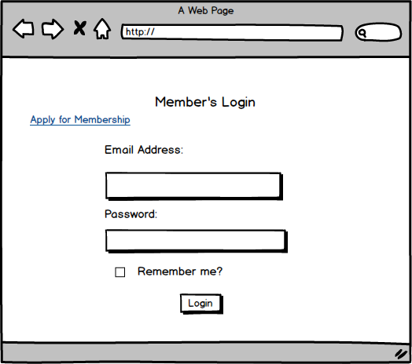

*Fig 2 : Membership Login*

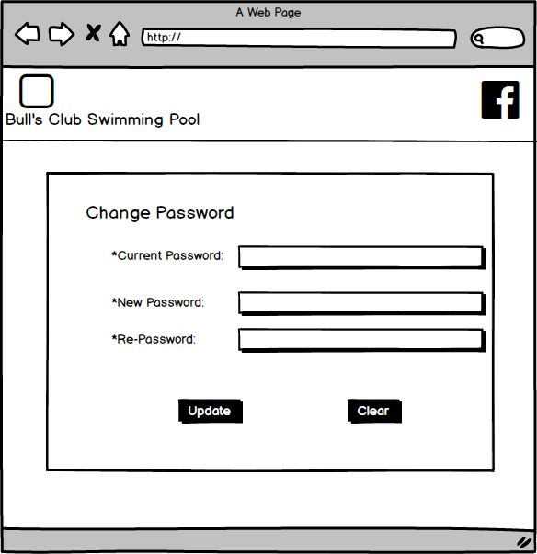

*Fig 3 : Change Password*

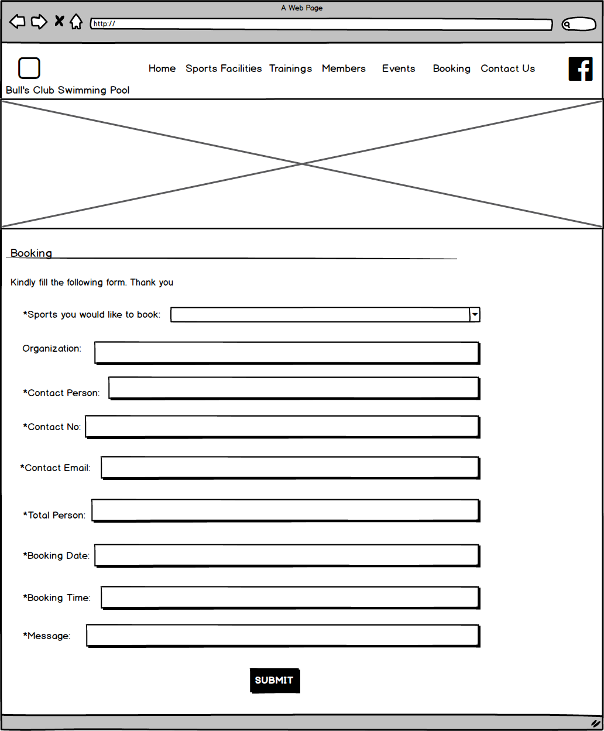

*Fig 4 : Booking form*

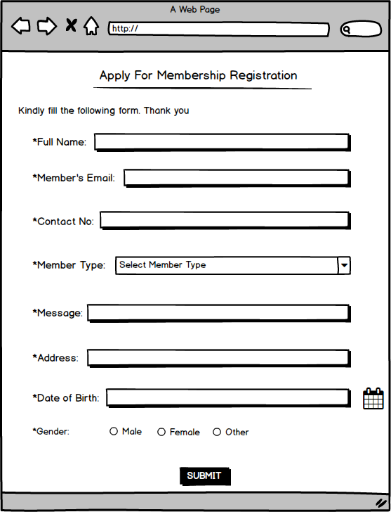

*Fig 5 : Membership Registration*

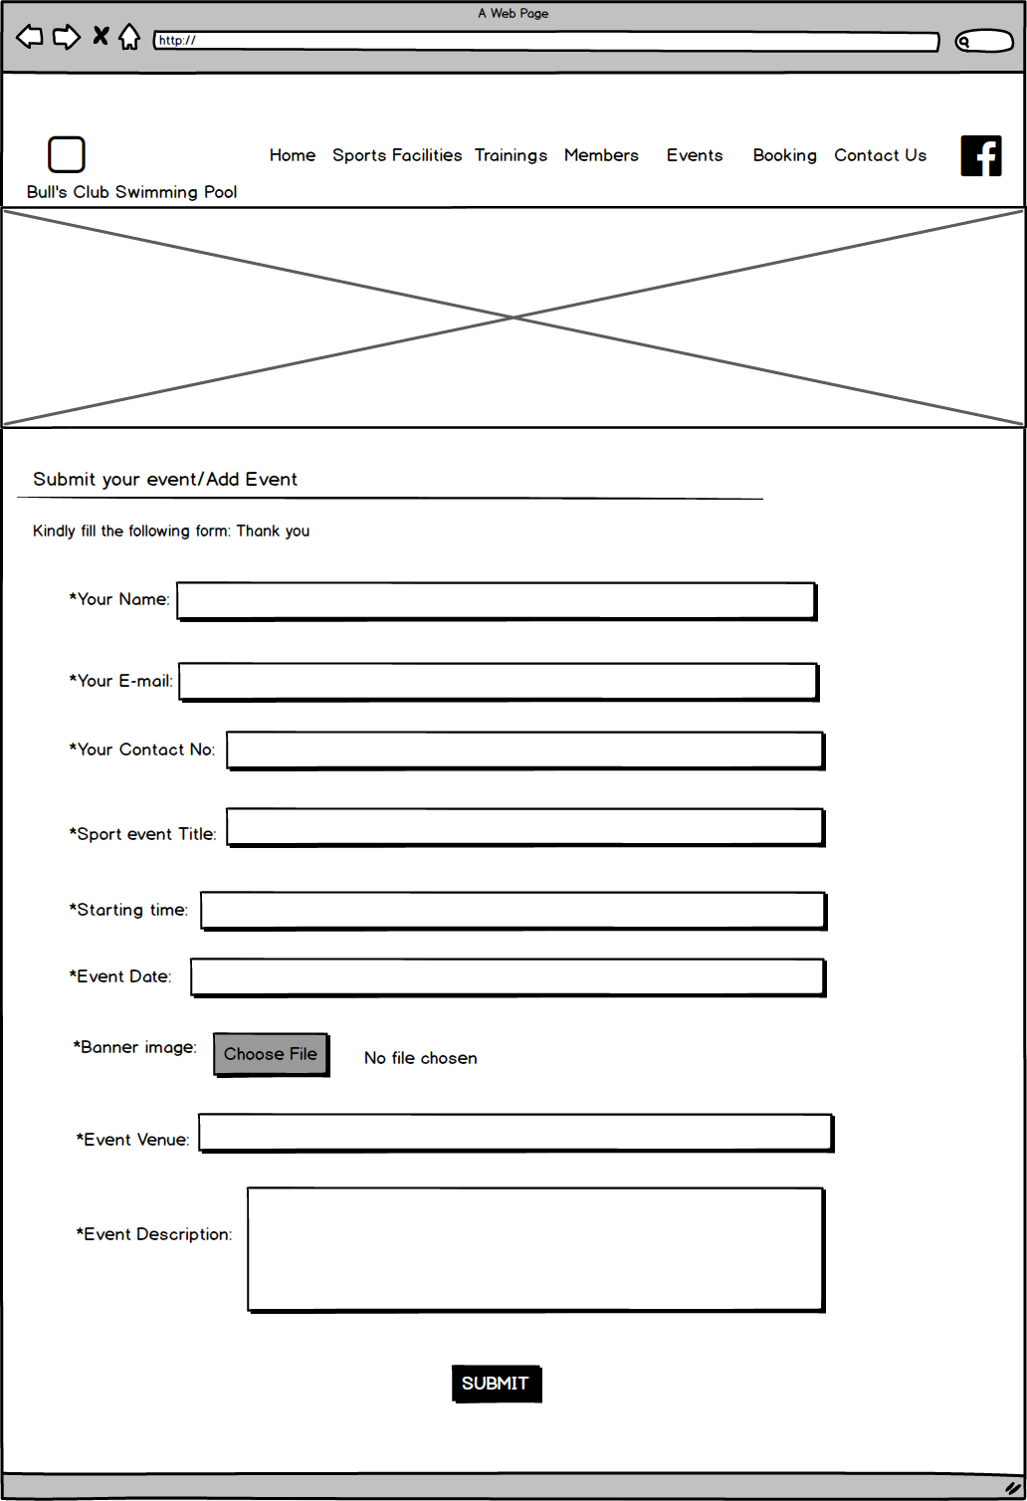

*Fig 6 : Submit or add event form*

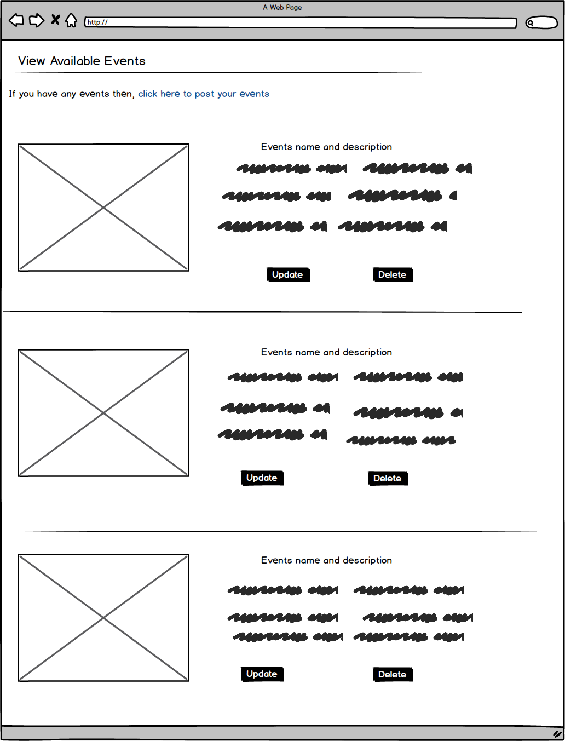

*Fig 7: view, update, delete, description of event*

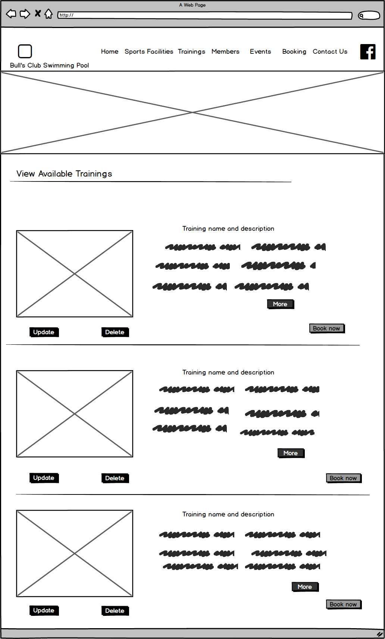

*Fig 8: view, update, delete, description, book of training*

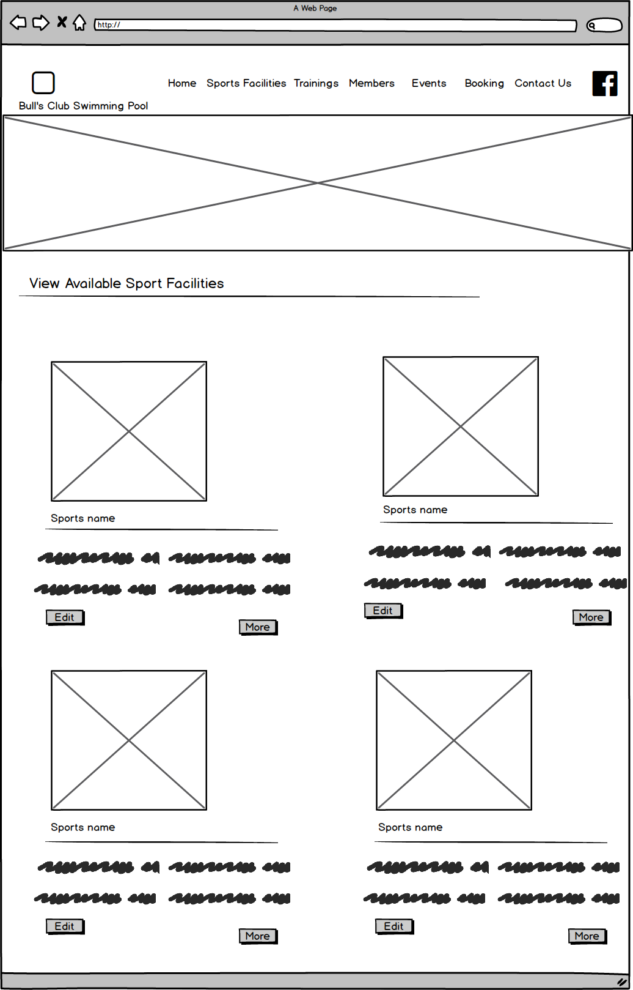

*Fig 9: view, edit and description of sports facilities*

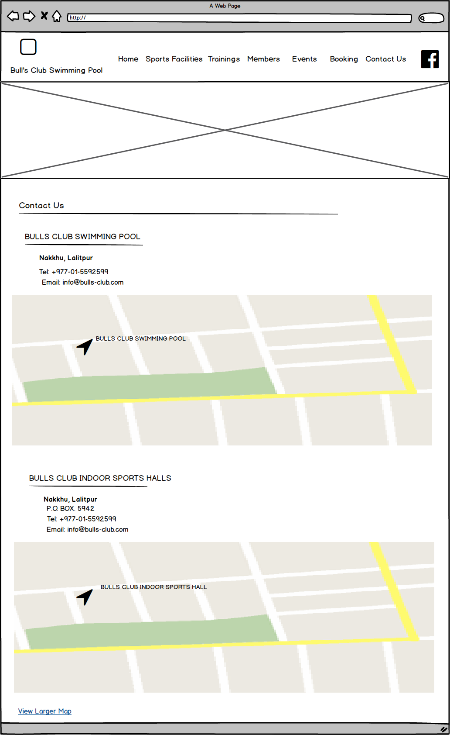

*Fig 10: Contact Us details*

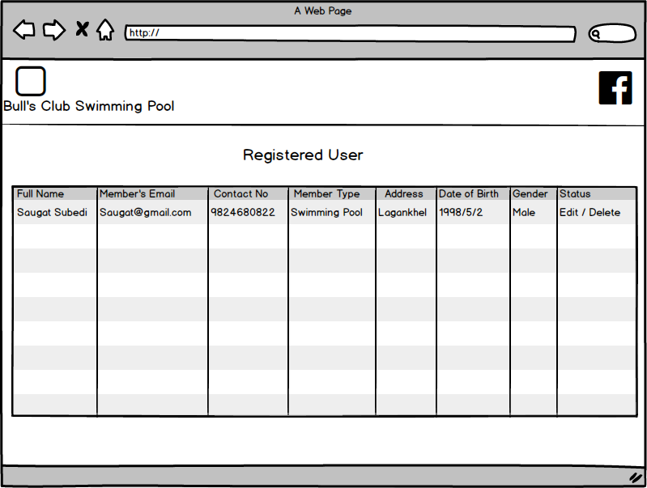

*Fig 11: View Registered Users*

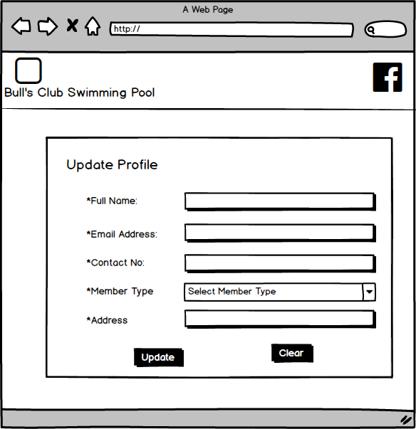

*Fig 12: Update User’s Details*

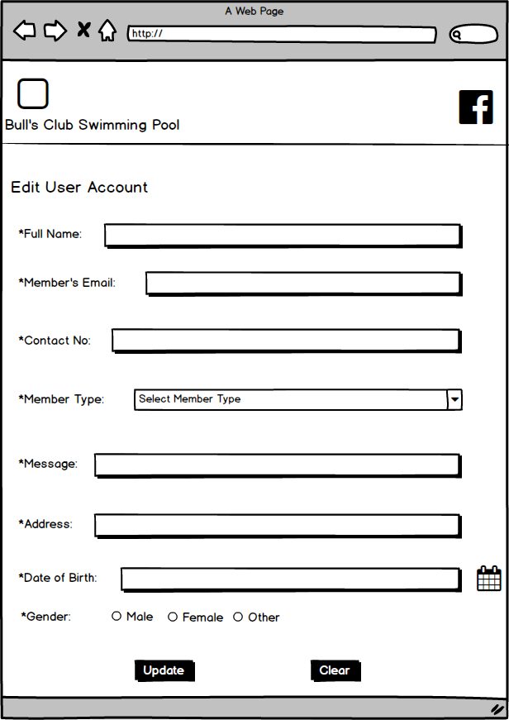

*Fig 13: Admin Edit User*